
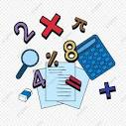
English
Writing
Our key text this half term is the book of Hopes We will explore key aspects of narrative (plot, character, setting, theme) and the devices that authors deploy to develop and link these. The children will revise and build on their knowledge of grammatical terms, complex sentences, clauses, conjunctions, and sentence punctuation.

Reading
In reading, the children will read and discuss an increasingly wide range of fiction, poetry, plays, nonfiction and reference books or textbooks. Reading books that are structured in different ways, for a range of purposes. We encourage daily reading at home and use our Accelerated Reader programme to monitor your child’s independent reading practice.

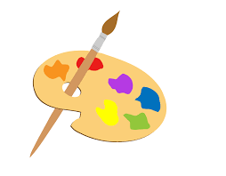

MFL – Spanish
This half term we will be learning to say the date and learn the months of the year. We will be learning about clothes and how to say what we and our friend are wearing; we will end the unit with a Spanish fashion show!

DT
In DT we will be looking at cooking and nutrition this term, celebrating culture and seasonality. We will find out where our food comes from and the need for a varied and healthy diet. We will finish the half term by making some yummy bread.

Topic Maya
History
The children will learn about different aspects of the Maya civilisation of Central America. They will investigate the magnificent ceremonial cities in the jungles of Central America. Pupils will be able to identify, describe and explain the purpose of the different religious and ceremonial buildings that existed in Maya cities. They will take part in a detailed case study of the Maya city – Chichen Itza. They will also find out about the great achievements of Maya society, including how they used hieroglyphs, number systems and the constellations in the night sky.

Maths
Our mathematical learning this half term will start with place value. We will read, write, order, and compare numbers up to 1 million and determine the value of each digit. We will move on to multiply and divide numbers by 10, 100 and 1000 and rounding numbers. We will then start adding and subtracting 4-digit numbers using the column method and inverse operations. We will also apply our knowledge to tackle multi-step problem solving and reasoning challenges.

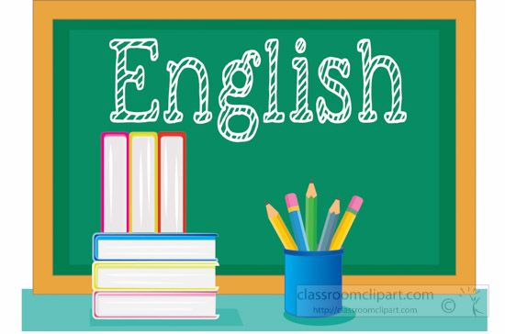
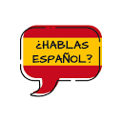
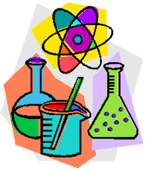
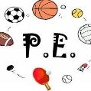


Home Learning
The children will have a small home learning task and some spellings to learn every week. This will be given out on Mondays and due back in the following Monday. We encourage children to read to an adult, if possible, every night as this helps to build fluency and vocabulary accusation.
Blended Learning
We’ll continue to use Microsoft Teams in school as a learning tool for the children, which can also be accessed at home using your child’s username and password.
Computing
Computing systems and networks - In this unit we will explore how data is transferred over the internet. Initially, we will focus on addressing, before moving on to the makeup and structure of data packets. The children will then look at how the internet facilitates online communication and collaboration; they complete shared projects online and evaluate different methods of communication.
PSHE
The children will set personal goals, know what they value most about their school and identify their hopes for this school year. We will discuss what it means to have rights and responsibilities as a citizen of our country. We will learn how democracy works and how having a voice benefits the school community.

Autumn Term 1 – The Maya
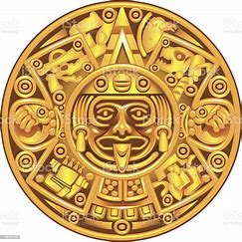
Upper Dart Curriculum Map

