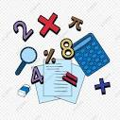
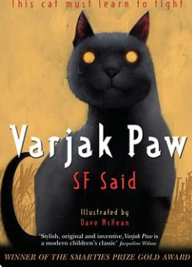
English
This half term we are reading Varjak Paw and will be practising
creating character and atmosphere through writing an
additional adventure for Varjak in the style of the author.

In reading, the children will read and discuss an increasingly wide range of fiction, poetry, plays, nonfiction and reference books or textbooks. Reading books that are structured in different ways, for a range of purposes. We encourage daily reading at home and use our Accelerated Reader programme to monitor your child’s independent reading practice.

MFL– Spanish
In Spanish this term, we will be looking
at housing and home; gathering an awareness of cultural differences when it comes to living habits. We will be identifying and sorting, nouns, adjectives, verbs and prepositions and trying new ways to commit language to memory.
Art
In art, we will be studying the work of Henri Matisse and Teddi Parker. We will build on our knowledge of colour theory , using complementary colours to create contrast and harmonious colours to mute tones.

Topic – Why is Fair Trade Fair?
Geography
The children will investigate the interconnectedness and interdependence of the world in which they live – 45 per cent of everything that young people in the United Kingdom eat and 90 per cent of everything they wear comes from abroad. This enquiry enables pupils to understand what international trade entails – the manufacture, selling and buying of goods and services between countries through exports and imports.

Maths
This half term we will be ordering decimals up to three decimal places and adding, subtracting, multiplying, and dividing them. We will go on to comparing them to fractions and percentages, ordering and finding equivalents.

Fair Trade
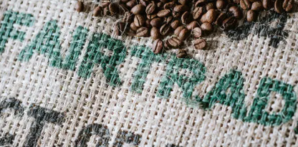
Upper Dart Curriculum Map
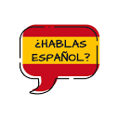

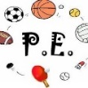


Home Learning
The children will have a small home learning task and some spellings to learn every week. This will be given out on Mondays and due back in the following Monday. We encourage children to read to an adult, if possible, every night as this helps to build fluency and vocabulary accusation.
Blended Learning
We’ll continue to use Microsoft Teams in school as a learning tool for the children, which can also be accessed at home using your child’s username and password.
Computing
We will be learning how to create variables in computer games. This unit explores the concept of variables in programming through games in Scratch. First, learners find out what variables are and relate them to real-world examples of values that can be set and changed.
PSHE
We will be finding out how to take responsibility for our health and make choices that benefit health and well-being. We will be investigating ways to care for our own physical and emotional health. We will be exploring factors that can improve, and those that can damage both our emotional and physical health and who can support and advise us along the way.

