
Topic – Ancient Greeks
History
This half term, we will be studying the conflict between Ancient Greek city-states, Athens and Sparta, which fought ferociously for almost 27 years. We will explore another inter-city conflict ,the Trojan War, involving Sparta and the emerging city of Troy. We will look the tale of the Trojan Horse, reviewing a number of secondary resources to help us determine if this story is fact, myth or legend.

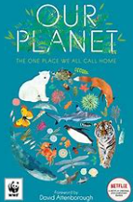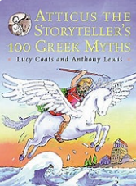

Ancient Greeks
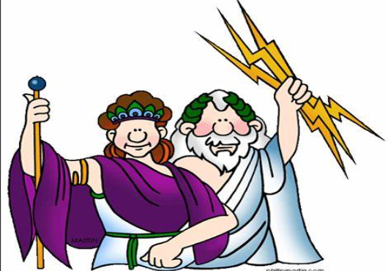
Upper Dart Curriculum Map
English

We will be continuing to work on an information text about our oceans influenced by the text Our Planet. We then move on to read Atticus the Storyteller and learn about many of the classic Greek myths. The children will write their own version of one of the myths we have studied.
Reading
In reading, the children will read and discuss an increasingly wide range of fiction, poetry, plays, nonfiction and reference books or textbooks. Reading books that are structured in different ways, for a range of purposes. We encourage daily reading at home and use our Accelerated Reader programme to monitor your child’s independent reading practice.

MFL – Spanish
In Spanish this term we will be making a family tree and talking about our family members. We will then go on to say where they live and what jobs they have.
Art
In art, we will be practising tone and texture in drawing. We will then look at the tone in painting, studying the work of Henri Matisse and Teddi Parker. We will build on our knowledge of colour theory , using complementary colours to create contrast and harmonious colours to mute tones.

Maths
This half term is all about fractions. We will start by recognising and finding equivalent fractions, then we will be converting improper fractions to mixed numbers and vice versa. We will then compare and order fractions and then add and subtract fractions and mixed numbers.






Home Learning
The children will have a small home learning task and some spellings to learn every week. This will be given out on Mondays and due back in the following Monday. We encourage children to read to an adult, if possible, every night as this helps to build fluency and vocabulary accusation.
Blended Learning
We’ll continue to use Microsoft Teams in school as a learning tool for the children, which can also be accessed at home using your child’s username and password.
Computing
Creating media, video production
This unit gives learners the opportunity to learn how to create short videos in groups. As they progress through this unit, they will be exposed to topic-based language and develop the skills of capturing, editing, and manipulating video.
PSHE
In this unit we will be thinking about our dreams and goals, what motivates us and what we need to do to achieve our aims. We will be discussing the role money will have in our lives and what types of jobs we would like to do. Wee will also be looking at what we can do to encourage and support others to achieve their aspirations.

